LAB EXPERIMENT RECORD
Set 22: Time Series Analysis

Department | AIML
Course Code / Course Name | DSA0601 / Data Handling and Visualization
Experiment | Data Visualization using R
Name | G. Ganga Chandrika
Register Number | 1925260144
Date | 17 October 2026
Day | Saturday

Aim
To analyse monthly sales data using a time series line chart, a scatter plot, a dashboard combining a line chart and pie chart, and an autocorrelation plot in R.
Dataset: Monthly Sales Data
Month | Sales (in $)
January | 15000
February | 18000
March | 22000
April | 20000
May | 23000

PROGRAM 1: Time Series Line Chart
In R, create a time series line chart to visualize the trend in monthly sales. Label the axes and title the chart.
# Monthly Sales Data
month <- c("January", "February", "March", "April", "May")
sales <- c(15000, 18000, 22000, 20000, 23000)
# Create a time series line chart
plot(sales,
type = "o",
col = "blue",
pch = 16,
xaxt = "n",
xlab = "Month",
ylab = "Sales (in $)",
main = "Monthly Sales Trend")
# Add month names to X-axis
axis(1, at = 1:5, labels = month)
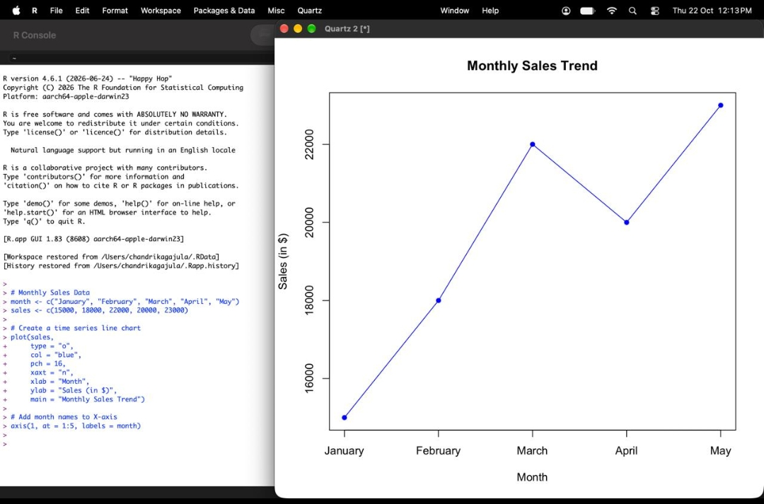
Output 1: Monthly Sales Trend Line Chart
Observation: Sales rise from $15,000 in January to $22,000 in March, dip to $20,000 in April, and reach the highest value of $23,000 in May, showing an overall upward trend.

PROGRAM 2: Scatter Plot of Advertising Budget vs Monthly Sales
In R, generate a scatter plot to analyze the relationship between advertising budget and monthly sales. Explain any insights.
# Monthly data
month <- c("January", "February", "March", "April", "May")
sales <- c(15000, 18000, 22000, 20000, 23000)
# Example advertising budget
advertising <- c(2000, 3000, 4000, 3500, 5000)
# Create scatter plot
plot(advertising, sales,
main = "Advertising Budget vs Monthly Sales",
xlab = "Advertising Budget (in $)",
ylab = "Sales (in $)",
col = "red",
pch = 19)
# Add trend line
abline(lm(sales ~ advertising), col = "blue", lwd = 2)
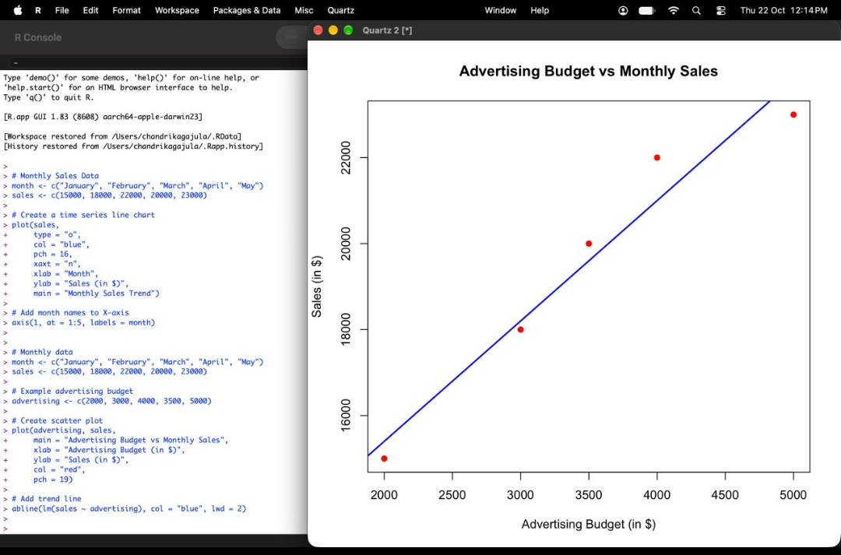
Output 2: Advertising Budget vs Monthly Sales Scatter Plot
Insight: The points lie close to the blue trend line and rise from left to right, showing a strong positive relationship between advertising budget and monthly sales (correlation of about 0.98 for the values used). Higher advertising spending is associated with higher sales. With only five data points this shows association, not proof that advertising causes the increase.

PROGRAM 3: Dashboard of Sales Trend and Product Sales Distribution
In Tableau, build a dashboard combining a line chart showing sales trend and a pie chart displaying the distribution of sales across products.
# Monthly Sales Data
month <- c("January", "February", "March", "April", "May")
sales <- c(15000, 18000, 22000, 20000, 23000)
# Product Sales Data (example values)
product <- c("Laptop", "Mobile", "Tablet", "Headphones")
product_sales <- c(40000, 30000, 20000, 10000)
# Save the current graphical settings
oldpar <- par(no.readonly = TRUE)
# Create dashboard with two plots
par(mfrow = c(1, 2))
# Line Chart: Monthly Sales Trend
plot(1:5, sales,
type = "o",
col = "blue",
pch = 16,
xaxt = "n",
main = "Monthly Sales Trend",
xlab = "Month",
ylab = "Sales (in $)")
axis(1, at = 1:5, labels = month, las = 2)
# Pie Chart: Product Sales Distribution
pie(product_sales,
labels = product,
col = rainbow(4),
main = "Product Sales Distribution")
# Add an overall dashboard title
mtext("Monthly Sales Analysis Dashboard",
outer = TRUE, cex = 1.3)
# Restore graphical settings
par(oldpar)
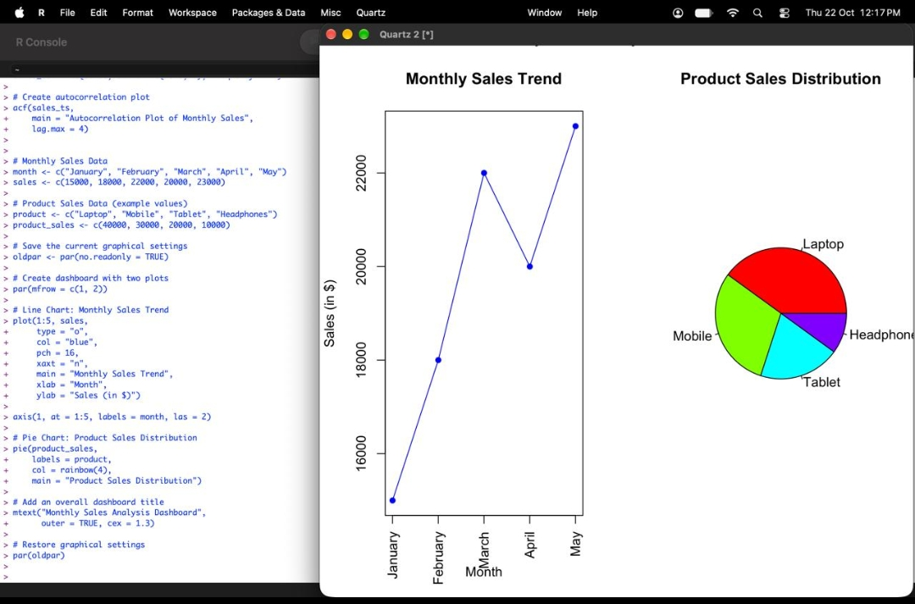
Output 3: Dashboard - Monthly Sales Trend and Product Sales Distribution
Observation: The dashboard places the monthly sales line chart beside the pie chart of product sales. The line chart shows the upward sales trend, and the pie chart shows Laptop as the largest share (40%), followed by Mobile (30%), Tablet (20%) and Headphones (10%).

PROGRAM 4: Autocorrelation Plot of Monthly Sales
In R, create an autocorrelation plot to identify seasonality in the time series data.
# Monthly sales data
sales <- c(15000, 18000, 22000, 20000, 23000)
# Create time series object
sales_ts <- ts(sales, start = c(2026, 1), frequency = 12)
# Create autocorrelation plot
acf(sales_ts,
main = "Autocorrelation Plot of Monthly Sales",
lag.max = 4)
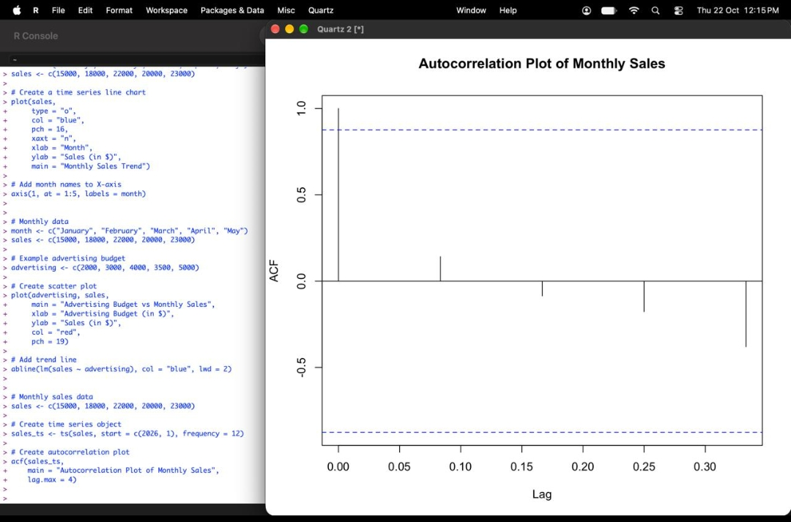
Output 4: Autocorrelation Plot of Monthly Sales
Observation: The ACF is 1.0 at lag 0 (always the case). At the later lags the values are small and mostly negative, and none cross the blue dashed significance limits. This shows no clear repeating seasonal pattern in this short series of five months; the rise in sales is better explained as a trend.

Procedure
1. Create the month and sales vectors in R.
2. Use plot() with type = "o" and axis() to draw the time series line chart with labelled axes and a title.
3. Create an advertising budget vector of equal length, use plot() for the scatter plot, and add a trend line with abline(lm()).
4. Create the product sales data, use par(mfrow = c(1, 2)) to place a line chart and a pie chart side by side, and add an overall title with mtext().
5. Convert the sales data to a time series using ts() and draw the autocorrelation plot using acf().
Result
The monthly sales data was analysed using a time series line chart, a scatter plot with trend line, a dashboard combining a line chart and pie chart, and an autocorrelation plot.
Key R Functions Used
Function | Purpose
plot() | Creates line and scatter plots.
axis() | Adds custom axis labels.
abline() | Adds a trend line to a plot.
lm() | Fits a linear regression model.
pie() | Creates pie charts.
par() | Sets or restores graphical parameters such as mfrow.
mtext() | Adds an overall title to the dashboard.
ts() | Creates a time series object.
acf() | Draws the autocorrelation plot.

